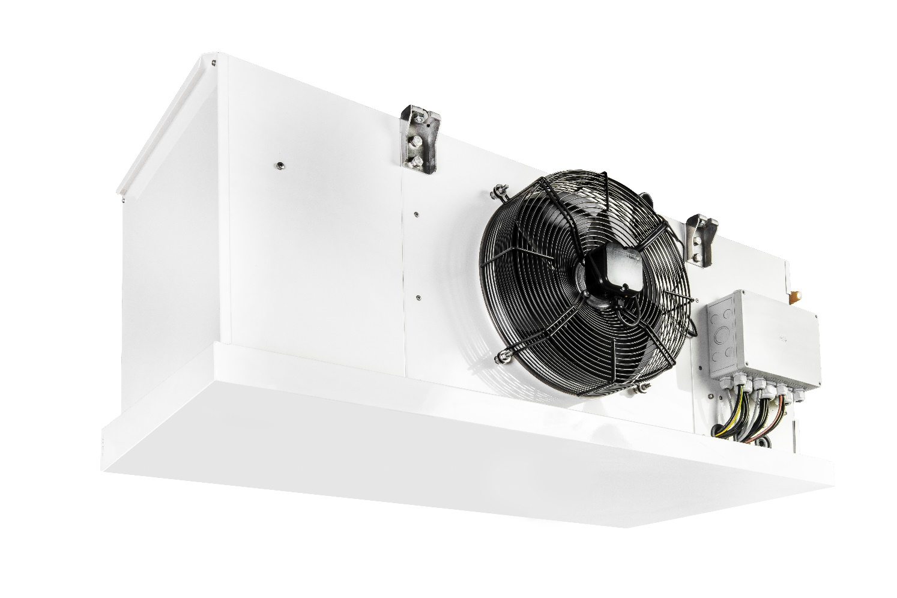

Illustration 1 MultiLowChill example

**Refrigeration machine** xxx kW

Liquid-cooled air cooler for cooling or deep-freeze applications with the natural refrigerant CO2 (R744) in a compact design and low filling quantities. Installation takes place directly in the cold room and with a refrigeration cycle ready for delivery. All components necessary for cooling are contained in the housing.

The MultiLowChill can be used as a single device or when using multiple devices in a network. A high total cooling capacity and redundancy are thus available.

**Housing**

The housing is provided with a high quality powder coating. For ceiling mounting, this is equipped with 4 stable eyelets. All components such as compressors, evaporators, desuperheaters, condensers, expansion tanks, switching and safety devices are compactly housed in the housing. For fast and energy-saving defrosting, the evaporator is equipped as standard with a defrosting valve and a double-insulated condensate tray.

**Compressor**

Semi-hermetic reciprocating compressor with high efficiency, engine protection, oil sump heater, rubber vibration damper, oil pump and oil filling. The compressor is approved for use with the refrigerant R744 (CO2). The power control is carried out via frequency control as standard.

**Plate heat exchanger**

The refrigerant is liquefied by a purchaser’s brine system (≤ -5°C).

**Evaporator**

The heat absorption in the evaporator takes place through dry expansion. The stepped lamella division (7 / 14mm) prevents the evaporator package from freezing over quickly. This means that defrosting is less necessary, which enables efficient operation. An electrical defrost heater is standard in the evaporator package and the condensate tray.

**Refrigeration cycle**

In addition to the central components, the subcritical refrigeration circuit includes the compressor, evaporator and plate heat exchanger for condensation, an electronic expansion valve as standard, temperature sensors, pressure sensors for high and low pressure, service valves for high and low pressure, pressure switches, pressure limiters and safety pressure limiters depending on the design. The cold-conducting components are provided with closed-cell insulation. All components are suitable and approved for use with the refrigerant R744 (CO2).

**Type-tested security systems**

In order to prevent the safety valves from responding in warm ambient temperatures (≤ + 40°C), an expansion tank is integrated in the device. This ensures reliable operating behaviour without loss of refrigerant.

**Control**

The control (available separately) is based on a high-quality Siemens Climatix PLC. The power control of the MLC takes place via a frequency control. The control cabinet can be designed as a stand or wall cabinet. This is also optionally available in stainless steel.

**Control main components:**

* Main switch with emergency stop function
* Circuit breaker
* Automatic circuit breakers for every consumer
* Siemens Climatix control modules
* High quality control cabinet components
* incl. 1x control element Siemens POL 8xx for operation and fault evaluation
* 1x SD card for updating app and firmware Local service plug for user interface, installed software, control of MultiChiller
* Control of the electr. expansion valves
* Access via Modbus TCP or RTU
* Access via Ethernet and HMI for Web
* Frequency converter
* Optional access via BACnet IP or MSTP

**Equipment**

* Semi-hermetic reciprocating compressor
* Multichannel plate heat exchanger
* Expansion tank
* Electronic expansion valve
* Depending on the model, pressure switches, pressure limiters, safety pressure limiters
* Pressure sensors, temperature sensors
* Tripping device motor protection
* Thermal protection thermostat on the cylinder head
* Temperature controlled Oil sump heater
* High quality coated housing
* Retaining eyelets for ceiling mounting
* Basic module with its own Siemens Climatix
* Communication possible via BUS system
* Optional remote monitoring possible

|  |  |  |  |
| --- | --- | --- | --- |
| Air inlet temperature | °C | Bitte eintragen | |
| Recooling temperature (forward / return) | °C | Bitte eintragen | |
|  |  |  | |
| Cooling capacity | kW | Bitte eintragen | |
| staged power control |  | frequency control | |
| Condensing capacity | kW | Bitte eintragen | |
| Vaporisation temperature | °C | Bitte eintragen | |
| Mainhost power supply | V / PH / Hz | 400 / 3 / 50 | |
| Maximum electrical absorption | A | Bitte eintragen | |
| Refrigerant |  | Carbon dioxide (R477) | |
| Refrigerant charge | kg | Bitte eintragen | |
| Cold transfer medium |  | Bitte eintragen | |
|  |  |  | |
| Compressor type |  | semi-hermetic reciprocating compressor | |
| Number of compressors |  | 1 | |
| Power levels frequency converter |  | frequency control | |
| Max. power consumption | kW | Bitte eintragen | |
| Maximum electrical absorption | A | Bitte eintragen | |
|  |  |  | |
| Type |  | Evaporator | |
| Fan Mainhost power supply |  | Bitte eintragen | |
| Fan number |  | Bitte eintragen | |
| Pipe / finned material |  | Cooper / aluminum | |
|  |  |  | |
| Block heater (230V/1PH/50Hz) | kW | Bitte eintragen | |
| Trough heater (230V/1PH/50Hz) | kW | Bitte eintragen | |
| Fan heater (230V/1PH/50Hz) | kW | Bitte eintragen | |
| Motor protection compressor |  | INT69 G | |
|  |  |  | |
| Interface forward / return recooling |  | Cooper pipe xx | |
| Connection power supply |  | Connecting terminal plate | |
|  |  |  | |
| D-Bus-Interface |  | Bitte Auswählen | |
| CPU |  | Siemens Climatix | |
| Visualisation |  | Bitte Auswählen | |
|  |  |  | |
| Sound pressure level in 3m | dB(A) | 55 | |
| Sound measurement acc. to EN 13487 |
|  |  |  | |
| Length | mm | 1600 |
| Width | mm | 860 |
| Height | mm | 680 |
| Transport weight | kg | ca. 220 |
| Average weight | kg | ca. 250 |

Liefernachweis:

FUTRON GmbH

Elisabethstraße 29 Phone: +49 37 65 38 03-0

08491 Netzschkau Mail: info@futron-gmbh.de

Germany