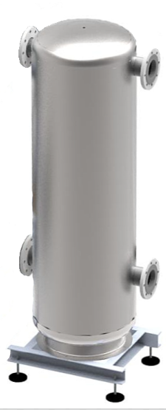

Abbildung 1 / MultiHydroSwitch MHS beispielgebend

MultiHydroSwitch - MHS

The MultiHydroSwitch was designed for the Futron MultiChiller kit and serves as a hydraulic switch to decouple the differential pressures between the refrigeration generator and the consumer side. Furthermore, this is also used as a buffer storage in smaller power ranges. The Futron MHS is used in systems with liquids (water, brine) for cooling and/or heating purposes.

The hydraulic switch is designed to complement the MultiHydro module. The MHS can also be used together with the MultiHydro and MultiHeatRecovery.

The filling volume of the module is 420 litres. It is possible to choose between different pipe dimensions depending on the connection. The selection ranges from aluminum loose flange PN10/16 from DN 80, DN 100 to DN 125. The pipes and the storage unit itself are made of stainless steel. The storage unit stands on a stable base frame and can be adjusted in height using adjustable feet. The MHS is provided with closed cell insulation. Mineral wool is used as insulation for warm brine systems.

Further information on the MultiHydroSwitch MHS according to the technical data sheet

Proof of delivery:

FUTRON GmbH

Elisabethstraße 29 Phone +49 37 65 38 03-0

08491 Netzschkau info@futron-gmbh.de

Germany

|  |  |  |
| --- | --- | --- |
| Medium |  | Bitte Auswählen |
| Material |  | stainless steel |
| System liquid temperature | °C | Bitte Ausfüllen |
| Insulation strength cold side | mm | Bitte Auswählen/Ausfüllen |
| Insulation strength warm side | mm | Bitte Auswählen/Ausfüllen |
| Max. Operating pressure | bar | 10 |
| Max. Operating temperature |  | 95 |
| Test pressure | bar | 13 |
|  |  |  |
|  |  |  |
|  |  |  |
|  |  |  |
| Warm brine inlet / outlet recooler |  | flange connection DN xx bolt circle-Ø xxx mm |
| Cold brine inlet / outlet cooling point |  | flange connection DN xx bolt circle -Ø xxx mm |
|  |  |  |
|  |  |  |
|  |  |  |
|  |  |  |
| Dearing and evacuation pipe collar | Zoll | ½ |
|  |  |  |
|  |  |  |
|  |  |  |
|  |  |  |
| Length | mm | 707 |
| Width | mm | 550 |
| Height | mm | ca. 1910 |
| Transport weight | kg | ca. 105 |
| Operating weight |  | ca. 550 |