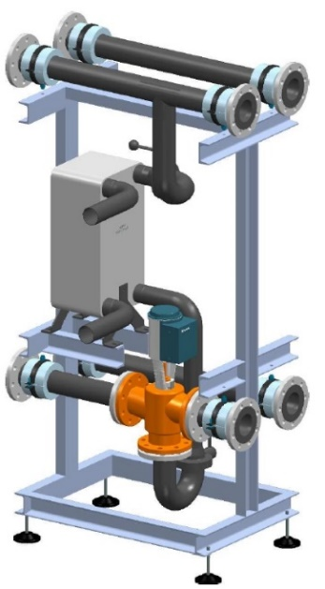

Illustration 1 / MultiHeatRecovery MHR example

MultiHeatRecovery - MHR is used for heat recovery using the waste heat in cooling mode.

The MultiHeatRecovery is designed for indoor installation and as a supplement to the MultiChiller kit. The MHR is available with different pipe dimensions to ensure that it can be easily flanged to the brine assembly (MultiHydro MH). The selection ranges from DN80 to DN100 to DN125. The connections of the plate heat exchanger, inlet and outlet of the brine, are soldering or welding sockets.

The desired heat recovery performance can be designed according to purchaser requirements. A 3-way mixing valve is installed for precise temperature distribution.

The MHR is mounted on a painted steel frame. The stainless steel pipes are installed in appropriate brackets. The module stands on a stable base frame and can be adjusted in height using adjustable feet. The MHR is insulated with mineral wool.

The MHR is designed to complement the MultiHydro module. It can also be used together with the MultiHydro and the MultiHydroSwitch.

The interfaces from the distributor (MultiHydro) and to the consumer / recooling side must be connected via an aluminum loose flange PN10 / 16 DN80, DN100 or DN125 (according to version).

The mixing valve can be equipped with an on-site or optional futron control.

*Important note: The MultiHeatRecovery cannot be operated without a controller.*

Further information on the MultiHeatRecovery MHR according to the technical data sheet.

Proof of delivery:

FUTRON GmbH

Elisabethstraße 29 Phone +49 37 65 38 03-0

08491 Netzschkau info@futron-gmbh.de

Germany

|  |  |  |
| --- | --- | --- |
| Heat transfer medium |  | Bitte Auswählen |
| Thermal output | kW | Bitte Ausfüllen |
| Plant volume cold brine | L | Bitte Ausfüllen |
| Plant volume warm brine | L | Bitte Ausfüllen |
| System liquid temperature | °C | Bitte Ausfüllen |
| Plant operating pressure | bar | Bitte Ausfüllen |
| Max. Operating pressure | bar | Bitte Ausfüllen |
| Heat recovery primary ON/OFF | °C | Bitte Ausfüllen |
| Heat recovery primary flow | m³/h | Bitte Ausfüllen |
| Heat recovery primary pressure loss | kPa | Bitte Ausfüllen |
| Medium secondary |  | Bitte Auswählen |
| Heat recovery secondary ON/OFF | °C | [Kommentare] |
| Heat recovery secondary flow | m³/h | Bitte Ausfüllen |
| Heat recovery secondary pressure loss | kPa | Bitte Ausfüllen |
|  |  |  |
|  |  |  |
|  |  |  |
|  |  |  |
| Warm brine inlet / outlet recooler |  | flange connection DN xx bolt circle-Ø xxx mm |
| Cold brine inlet / outlet cooling point |  | flange connection DN xx bolt circle -Ø xxx mm |
| Consumer plate heat exchanger - entry |  | Victaulic Ø 42,4mm |
| Consumer plate heat exchanger - exit |  | Victaulic Ø 42,4mm |
|  |  |  |
|  |  |  |
|  |  |  |
|  |  |  |
| Length | mm | Bitte Ausfüllen |
| Width | mm | Bitte Ausfüllen |
| Height | mm | Bitte Ausfüllen |
| Transport weight | kg | Bitte Ausfüllen |