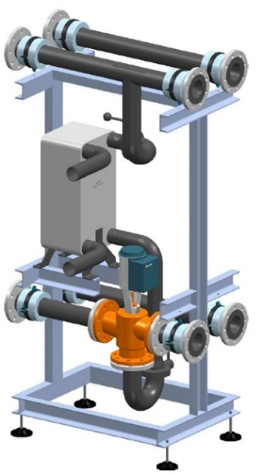
Illustration 1 / MultiHeatRecovery MHR example

MultiHeatRecovery - MHR is used for heat recovery using the waste heat in cooling mode.

The MultiHeatRecovery is designed for indoor installation and as a supplement to the MultiChiller kit. The MHR is available with different pipe dimensions to ensure that it can be easily flanged to the brine assembly (MultiHydro MH). The selection ranges from DN80 to DN100 to DN125. The connections of the plate heat exchanger, inlet and outlet of the brine, are soldering or welding sockets.
The desired heat recovery performance can be designed according to purchaser requirements. A 3-way mixing valve is installed for precise temperature distribution.

The MHR is mounted on a painted steel frame. The stainless steel pipes are installed in appropriate brackets. The module stands on a stable base frame and can be adjusted in height using adjustable feet. The MHR is insulated with mineral wool.

The MHR is designed to complement the MultiHydro module. It can also be used together with the MultiHydro and the MultiHydroSwitch.

The interfaces from the distributor (MultiHydro) and to the consumer / recooling side must be connected via an aluminum loose flange PN10 / 16 DN80, DN100 or DN125 (according to version).

The mixing valve can be equipped with an on-site or optional futron control.
Important note: The MultiHeatRecovery cannot be operated without a controller.

Further information on the MultiHeatRecovery MHR according to the technical data sheet.

Proof of delivery:
FUTRON GmbH
Elisabethstraße 29 Phone +49 37 65 38 03-0
08491 Netzschkau info@futron-gmbh.de
Germany

Heat transfer medium |  | Bitte Auswählen
Thermal output | kW | Bitte Ausfüllen
Plant volume cold brine | L | Bitte Ausfüllen
Plant volume warm brine | L | Bitte Ausfüllen
System liquid temperature | °C | Bitte Ausfüllen
Plant operating pressure | bar | Bitte Ausfüllen
Max. Operating pressure | bar | Bitte Ausfüllen
Heat recovery primary ON/OFF | °C | Bitte Ausfüllen
Heat recovery primary flow | m³/h | Bitte Ausfüllen
Heat recovery primary pressure loss | kPa | Bitte Ausfüllen
Medium secondary |  | Bitte Auswählen
Heat recovery secondary ON/OFF | °C | [Kommentare]
Heat recovery secondary flow | m³/h | Bitte Ausfüllen
Heat recovery secondary pressure loss | kPa | Bitte Ausfüllen
Warm brine inlet / outlet recooler |  | flange connection DN xx bolt circle-Ø xxx mm
Cold brine inlet / outlet cooling point |  | flange connection DN xx bolt circle -Ø xxx mm
Consumer plate heat exchanger - entry |  | Victaulic Ø 42,4mm
Consumer plate heat exchanger - exit |  | Victaulic Ø 42,4mm
Length | mm | Bitte Ausfüllen
Width | mm | Bitte Ausfüllen
Height | mm | Bitte Ausfüllen
Transport weight | kg | Bitte Ausfüllen

