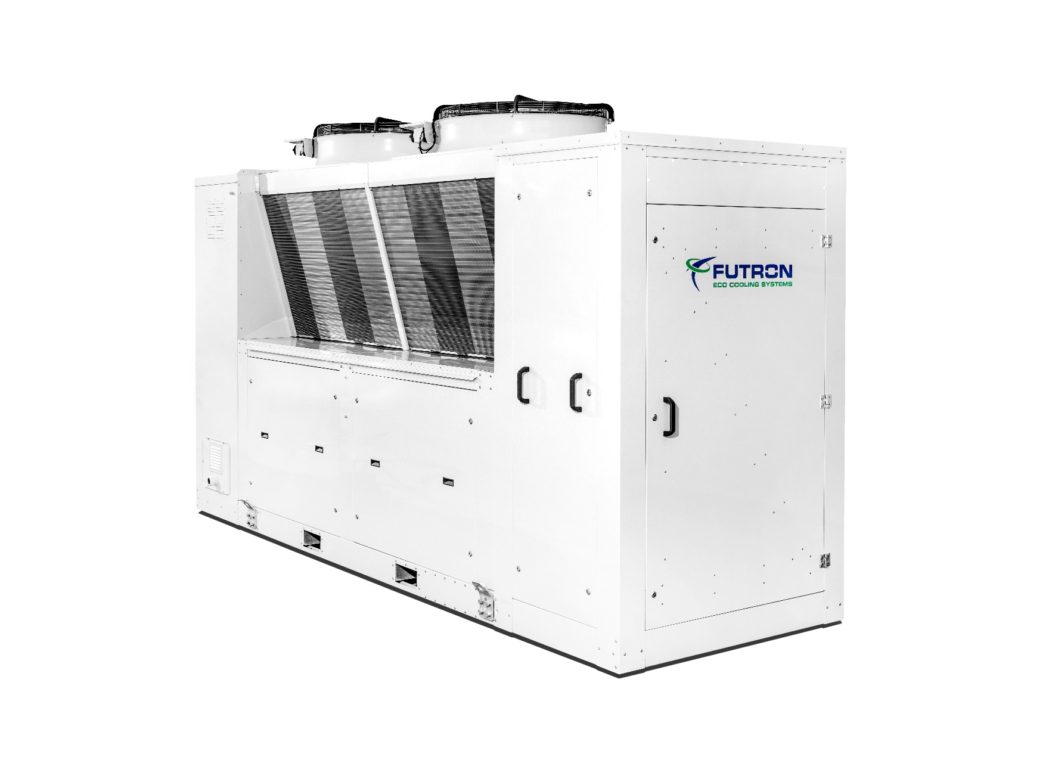

Illustration 1 MultiEcoChill example

**Refrigeration machine** xxx kW

Air-cooled liquid cooler for outdoor installation with natural refrigerants and minimal fill quantities.

Liquid chiller with a refrigeration cycle ready for delivery and staged power control (optional FU). The natural and energy-efficient refrigerants R290, R1270 or R600a are used as refrigerants. The brine chiller is suitable for high ambient temperatures >40° C and is supplied as a ready-to-connect unit.

The MultiEcoChill (MEC) contains 2 MultiChiller Model E as refrigeration generators. These are selected according to the respective requirements and performance requirements. One hot and one cold brine pump are integrated on each side of the MultiChiller. The MEC is optionally available with heat recovery or free cooling. For hydraulic decoupling, the MEC can be equipped with a low loss header on the cold brine side.

Due to the special design and component selection, an extremely low refrigerant charge is required, which is <40g/kW cooling capacity. Depending on the cooling capacity, the refrigerant charge is only 0.5 to 2.4 kg. This enables a safe installation in the general access area according to DIN EN 378-1.

No refrigeration personnel are required for installation and maintenance.

**Housing**

For the outdoor installation, the housing is provided with a high-quality powder coating and sound insulation. The components of the control cabinet, refrigeration with hydraulics and dry cooler are spatially separated from each other. The MEC is supplied on six height-adjustable feet with vibration dampers. This makes it possible to compensate for uneven floors and the MultiChiller can be adjusted to the position of the on-site connecting pipes. Cranes and forklifts are available for safe installation. There are inspection openings for service purposes.

**MultiChiller**

The MultiChiller as an innovative refrigeration generator includes, in addition to the central components, compressors and multi-channel plate heat exchangers, an electronic expansion valve, temperature sensors, pressure sensors for high and low pressure, service valves for high and low pressure, depending on the version, pressure monitors, pressure limiters and safety pressure limiters. Thanks to the specially developed multi-channel plate heat exchanger, the lowest refrigerant charge is possible.

The MultiChiller is also notable for its service convenience. Easy-to-use coupling systems (Victaulic® connection) are used on the hydraulic side of the MultiChiller. On the electrical side, the MultiChiller is connected to the control system via cable sets with a Plug´n´Play connector system. These enable simple and error-free connection when the MultiChiller is replaced. The cold-conducting components are provided with closed-cell insulation. All components are suitable and approved for use with hydrocarbons.

**Compressor**

Semi-hermetic reciprocating compressor with high efficiency, thermal protection thermostat per cylinder cover, engine protection, oil sump heating, rubber vibration damper, oil pump and special oil filling. The compressor is specially approved for use with hydrocarbons. The power control is carried out as standard via step control (cylinder deactivation). Frequency control is optionally available.

**Plate heat exchanger**

The multi-channel plate heat exchanger combines the functions of evaporator, condenser, subcooler and superheater. The refrigerant overheating is measured directly in the multi-channel plate heat exchanger after the evaporator. As a result, a small and safe refrigerant overheating can be measured. Thanks to this unique design, the expansion valve provides stable regulation without disruptive influences from the suction gas superheater.

**Hydraulics**

The MultiChillers contained in the MEC are each supplied by an energy-saving high-efficiency pump for hot and cold brine. There is also the option of adapting the advanced hydraulic components according to purchaser requirements. The components that can be selected are: hydraulic separator for decoupling between the generator and the consumer circuit, consumer pump, heat recovery and free cooling. The cold-conducting components are provided with closed-cell insulation. If heat recovery is optionally used, mineral wool is used to insulate the heat-conducting components.

**Type-tested security systems**

A safety trough is integrated in the closed housing base of the refrigeration unit. The components of the refrigeration circuit are installed above this. Any refrigerant that escapes can be retained in this sump. The system is equipped with a two-stage gas warning device (ATEX). The gas warning system is part of the safety concept. It is a separate circuit which, in the event of an increased refrigerant concentration, switches on the ATEX-safety fan for extraction in the first stage and can output a message to a permanently manned location via the control system. The MEC remains in operation. When the second warning threshold is reached, the safety fan remains switched on and the machine part of the system is switched off by the control system. A message can be issued to a permanently manned position.

**Recooler**

The dry cooler is integrated in the MEC housing and equipped with low-noise and maintenance-free EC fans. The drive motor, the fan blade and the supporting protective grille construction form an optimal ventilation unit. The EC fans ensure high energy efficiency via the condensing pressure control. All axial fans have a separate repair switch and are easy to service.

**Control**

The control cabinet is positioned on the front of the device and forms an optical unit. The control is a PLC that has been specially programmed for the functions of the MEC. The high-quality Siemens-S7 is used as a central control system. The visualization and fault evaluation is carried out via a Siemens TP700 Comfort Panel.

**Control main components:**

* Main switch with emergency stop function
* Soft start for motor current limiter
* Circuit breaker
* Siemens S7 control modules
* High quality control cabinet components
* incl. 1x control element Siemens Touch Display Simatic HMI for operation and fault evaluation
* 1x SD card for updating app and firmware Local service plug for user interface, installed software, control of MultiChiller
* Control of the electr. expansion valves
* Control of the flow temperature (cold or warm) by stepping the chiller
* Optional access via ISO on TCP
* Optionally with frequency converter

**Equipment**

* High redundancy due to two separate cooling circuits
* Semi-hermetic reciprocating compressor
* Multichannel plate heat exchanger
* Lowest refrigerant charge, less than 2.5kg / per refrigeration circuit
* Electronic expansion valve
* Depending on the model, pressure switches, pressure limiters, safety pressure limiters
* Two-stage gas warning system ATEX
* Safety suction
* Pressure sensors, temperature sensors
* Service connection high pressure, low pressure
* Tripping device motor protection
* Thermal protection thermostat on the cylinder head
* Oil sump heater
* Power controller
* High quality coated housing for outdoor installation
* Adjustable feet with vibration dampers
* Basic module with its own Siemens S7
* Plug`n`Play via flange connection of the pipeline and plug system for the control and power supply
* Dry coolers with EC fans
* High efficiency pumps
* Optional heat recovery
* Optional free cooling
* Optional hydraulic switch
* Optional communication possible via BUS system
* Optional remote monitoring possible

|  |  |  |
| --- | --- | --- |
| Temperature cold (forward / return) | °C | Bitte eintragen |
| Temperature warm (forward / return) | °C | Bitte eintragen |
| Cold transfer medium |  | Bitte eintragen |
| Warm transfer medium |  | Bitte eintragen |
|  |  |  |
| Maximum ambient temperature | °C | Bitte eintragen |
| Minimum ambient temperature | °C | Bitte eintragen |
|  |  |  |
| Cooling capacity | kW | Bitte eintragen |
| Condensing capacity | kW | Bitte eintragen |
| Power consumption in the design point | kW | Bitte eintragen |
| EER |  | Bitte eintragen |
| Maximum electrical absorption | A | Bitte eintragen |
| Mainhost power supply | V / PH / Hz | 400 / 3 / 50 |
|  |  |  |
| Refrigerant |  | Bitte Auswählen |
| Refrigerant charge | g | Bitte Auswählen |
| Compressor type |  | Bitte eintragen |
| Number of compressors |  | 2 |
| Power levels frequency converter |  | Bitte Auswählen |
| injection valve |  | Bitte Auswählen |
|  |  |  |
| Fan type |  | Bitte eintragen |
| Fan number |  | Bitte eintragen |
| Pipe / finned material |  | Copper/aluminum |
|  |  |  |
| forward / return cold |  | Bitte Auswählen |
| forward / return warm |  | Bitte Auswählen |
| Connection terminals supply line * |  | Connecting terminal plate 3L+N+PE |
| Floor mounting |  | 6x feet with vibration damper (height adjustable) |
| * The cable cross-section is to be calculated according to the applicable regulations and can vary depending on the cable length,  type of installation and other factors. | | |
|  |  |  |
| Sound pressure level in 10m | dB(A) | 59 |
|  |  |  |
| D-Bus-Interface |  | Bitte Auswählen |
| CPU |  | Siemens S7 |
| Visualisation |  | Bitte Auswählen |
|  |  |  |
| Gas detection system and Safety exhaust |  | Bitte eintragen |
| Integrated hydraulic switch |  | Bitte eintragen |
| Integrated with consumer pump | | Bitte eintragen |
| Heat recovery |  | Bitte eintragen |
| Free cooling |  | Bitte eintragen |
|  |  |  |
| Length | mm | 4500 |
| Width | mm | 1640 |
| Height with vibration dampers | mm | 2669 |
| Transport weight | kg | ca. 2800 |