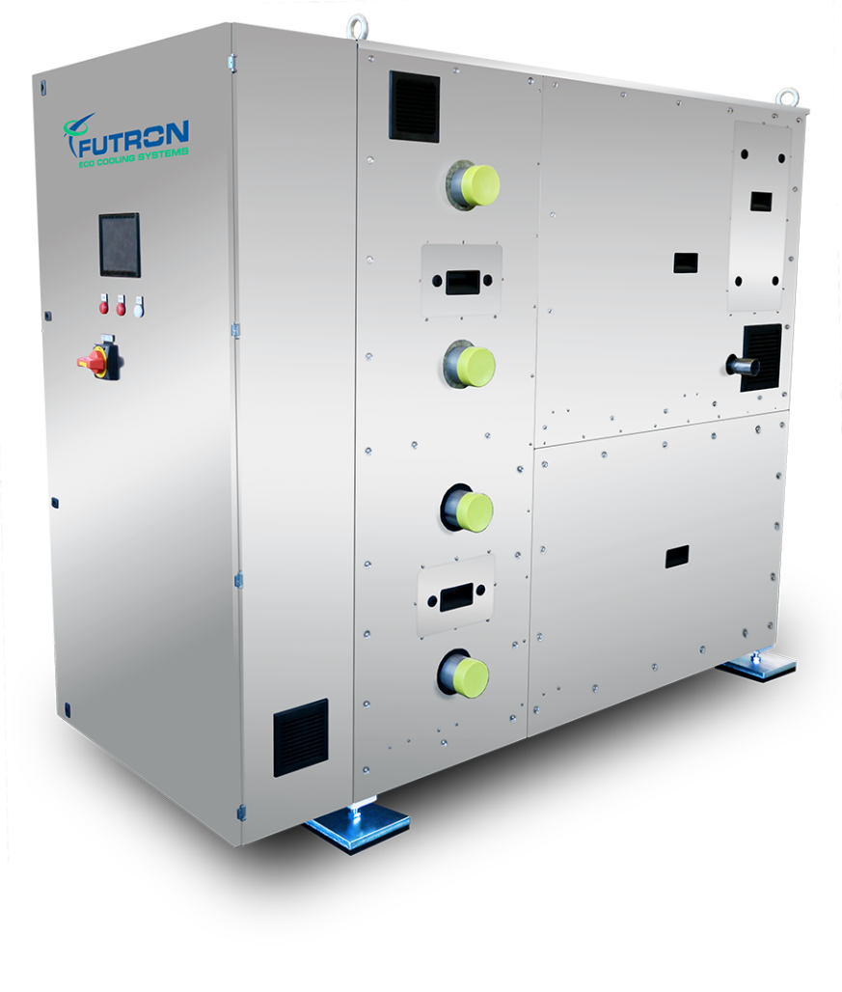
Abbildung 1 MultiChiller V-Serie beispielgebend

Refrigeration machine xxx kW
Water-cooled liquid cooler/heat pump for indoor installation in a compact design with natural refrigerants and minimal fill quantities. Compact, quiet and reliable liquid cooling unit/heat pump with a refrigeration circuit ready for operation upon delivery and a frequency-controlled compressor. The natural and energy-efficient refrigerants R290, R1270 or R600a are used as refrigerants.

The MultiChiller can be used as a single unit or in a hydraulic network with several units. This provides high cooling capacity and redundancy. Up to 8 MultiChiller VXL units can be controlled in a network. Furthermore, a MultiHeatRecovery MHR (sold separately) can be used for heat recovery and a MultiHydroSwitch MHS (sold separately) can be used as a hydraulic switch for decoupling.

Thanks to the special design and component selection, only a very small amount of refrigerant is required. Depending on the cooling capacity design, the refrigerant charge is only 3.0 to 3.8 kg per circuit. The MultiChiller has an integrated control system. Thanks to its compact dimensions and special safety system, the MultiChiller can be installed indoors despite the use of flammable refrigerants. The system also has no safety valve. No refrigeration technicians are required for installation and maintenance.
Housing
The housing of the MultiChiller is made of stainless steel and is supplied on four height-adjustable feet with vibration dampers. This allows for compensation of uneven floors and the MultiChiller can be adjusted to the position of the on-site connection pipes. The MultiChiller is designed for safe transport with a pallet truck or forklift. The housing cover can be removed for servicing purposes.
According to EN 378, the housing is classified as a ‘ventilated housing’.

Compressor
High-efficiency semi-hermetic reciprocating compressor, thermal protection thermostat per cylinder cover, motor protection, oil sump heater, rubber vibration dampers and special oil filling. The compressor is specially approved for use with hydrocarbons. Power control is provided as standard via frequency control.

Evaporator
A brazed plate heat exchanger with two refrigerant circuits and one brine circuit is used for dry evaporation. Patented channel routing and the structure of the refrigerant distributors ensure maximum efficiency. The heat exchanger is completely closed-cell insulated.

Condenser
A brazed plate heat exchanger with two refrigerant circuits and one brine circuit is used for condensation. This results in very good partial load behaviour. Patented channel routing and structure ensure maximum efficiency. The heat exchanger is insulated with mineral wool.

Desuperheater (optional)
A brazed plate heat exchanger with two refrigerant circuits and one brine/water circuit is used for the optional desuperheater. This enables heat to be extracted at a higher temperature level but with the same COP in heat pump applications.

Internal heat exchanger
The internal heat exchanger (superheating/subcooling) ensures significantly increased efficiency and reliable operation. It is integrated via the respective suction gas and liquid lines of each refrigeration circuit, resulting in the liquid refrigerant being subcooled before the expansion valve.

Refrigeration circuit (dual circuit, redundant)
In addition to the central components, compressors and plate heat exchangers, the two refrigeration circuits include an electronic expansion valve, temperature sensors, high and low pressure sensors, high and low pressure service valves, and, depending on the model, pressure switches, pressure limiters and safety pressure limiters as standard. The refrigerant-carrying components are equipped with closed-cell insulation. All components are suitable and approved for use with hydrocarbons.

Type-tested safety systems
A safety tray is integrated into the closed base of the refrigeration unit. The components of the refrigeration circuit are installed above this tray. Any refrigerant that may escape can be retained in this collection tray. The system is equipped with a two-stage gas warning device (ATEX). The gas warning system is part of the safety concept. It is a separate electrical circuit which only switches on the safety fan for extraction when the refrigerant concentration in the first stage is elevated and can send a message to a permanently manned station via the control system. The MultiChiller remains in operation. When the second warning threshold is reached, the safety fan remains switched on and the machine section with all refrigeration components is de-energised by the control system. A message can be sent to a permanently manned location.

Customer connections
The pipe connections on the unit are made on the outside via standardised DN80 Victaulic connections. The standardised connections enable quick and easy installation and removal by the installer.

Control
The device control is integrated into the MultiChiller VXL series. The control is a PLC specially programmed for the chiller's function. The high-quality Siemens Climatix components can be used as a combined or individual control. The chiller's output is regulated via frequency control. Up to 8 MultiChillers can be controlled with a combined control system.

Main components of the control system:
  - Main switch with emergency stop function
  - Motor protection switch
  - Siemens Climatix control modules
  - High-quality control cabinet components
  - Includes 1x 7" touch panel (Exor) for operation and fault analysis
  - 1x SD card for updating the app and firmware Local service connector for
  - User interface, installed software, control of the MultiChillers
  - Control of the electric expansion valve
  - Control of the flow temperature (cold or warm) by means of step switching of the chillers
  - Combined control of 2 or more chillers
  - Access via Modbus TCP or RTU
  - Access via Ethernet and HMI for Web
  - 2x frequency converters (PED)
  - Optional access via BACnet IP

Features MultiChiller
- Semi-hermetic reciprocating compressor
- Brazed plate heat exchangers
- Minimal refrigerant charge, less than 3.8 kg
- Electronic expansion valve
- Depending on model: pressure switch, pressure limiter, safety pressure limiter
- Two-stage gas warning system ATEX
- Safety extraction
- Pressure sensors, temperature sensors
- High-pressure and low-pressure service connection
- Motor protection release device
- Thermal protection thermostat on the cylinder head
- Oil sump heater
- Secondary connections via standardised flange connections
- Stainless steel housing
- Adjustable feet with vibration dampers
- Basic module with its own Siemens Climatix control system
- Communication via BUS system possible
- Remote monitoring possible
- Plug'n'play via flange connection of the pipeline

Cold temperature (flow/return) | °C | Bitte eintragen
Warm temperature (flow/return) | °C | Bitte eintragen
Maximum ambient temperature | °C | Bitte eintragen
Minimum ambient temperature | °C | Bitte eintragen
Cooling capacity | kW | Bitte eintragen
Condensing capacity | kW | Bitte eintragen
Power consumption at design point | kW | Bitte eintragen
EER |  | Bitte eintragen
Current consumption at design point | A | Bitte eintragen
Max. current consumption | A | Bitte Auswählen
Main power supply | V / PH / Hz | 380-420V Y/YY -3- 50Hz
Refrigerant |  | Bitte Auswählen
Refrigerant charge | g | Bitte Auswählen
Compressor type |  | Semi-hermetic reciprocating compressor
Number of compressors |  | 1
Power stages |  | Bitte Auswählen
Design |  | Multi-channel plate heat exchanger (brazed)
Material |  | Stainless steel / copper
Number of plate heat exchangers |  | 1
Injection valve |  | Bitte Auswählen
Coolant |  | Bitte Ausfüllen
Volume flow | m³/h | Bitte Ausfüllen
Pressure loss | kPa | Bitte Ausfüllen
Heat transfer medium |  | Bitte Ausfüllen
Volume flow | m³/h | Bitte Ausfüllen
Pressure loss | kPa | Bitte Ausfüllen
Gas warning system |  | 2-stage – ATEX
Safety extraction |  | Exhaust fan for combustible gases
Cold flow/return |  | Flange connection DN40
Hot flow/return |  | Flange connection DN40
Power supply connection
Extraction safety device |  | Pipe DN50
Floor mounting |  | 4x feet with vibration dampers (height-adjustable)
Sound pressure level at 5 m | dB(A) | Bitte Auswählen
Sound measurement according to DIN 45635 -1:1984-04 | dB(A) | Bitte Auswählen
Bus interface |  | Bitte Auswählen
CPU |  | Siemens Climatix
Visualisation |  | Bitte Auswählen
Length | mm | Bitte Auswählen
Width | mm | Bitte Auswählen
Height with vibration dampers | mm | Bitte Auswählen
Transport weight | kg | Bitte Auswählen

Proof of delivery:
FUTRON GmbH
Elisabethstraße 29
08491 Netzschkau
Telephone +49 37 65 38 03-0
info@futron-gmbh.de

