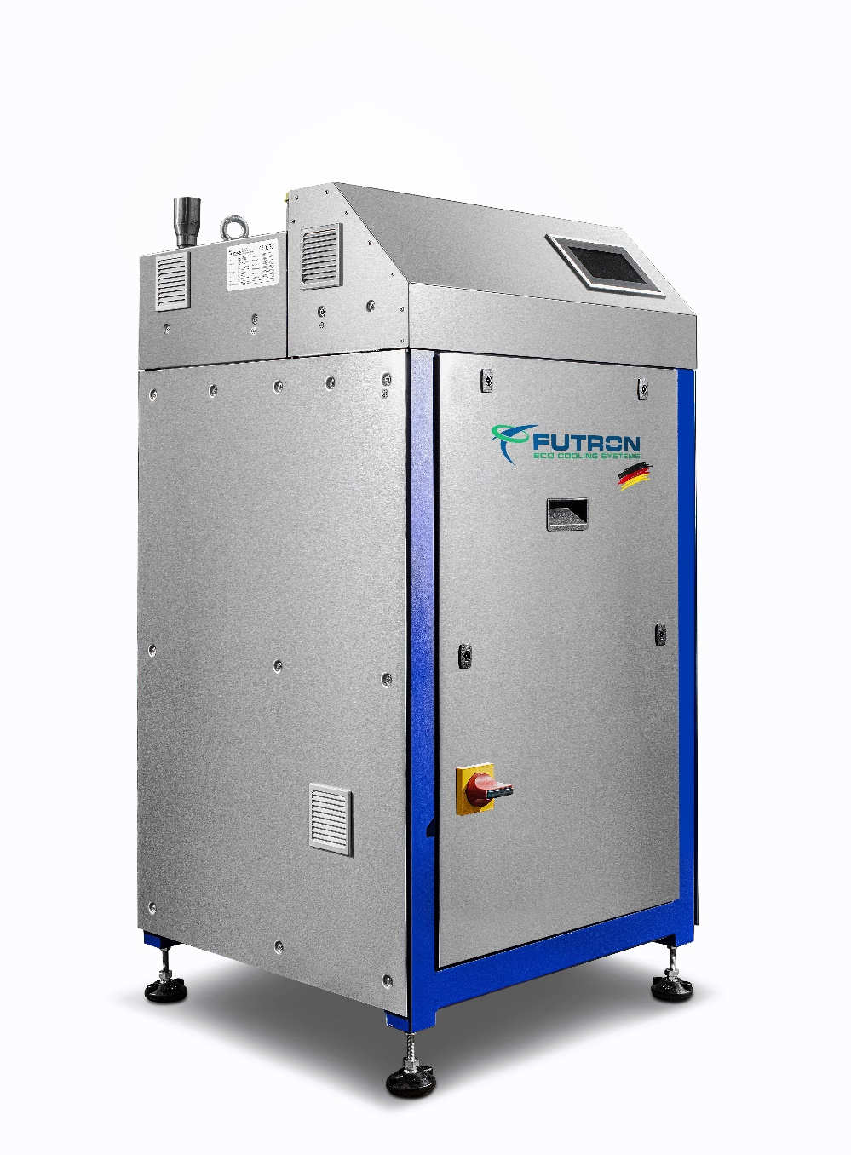

Illustration 1 MultiChiller example

**Refrigeration machine** xxx kW

Water-cooled liquid cooler for indoor installation in a compact design with natural refrigerants and minimal fill quantities.

Compact, quiet and reliable chiller with a ready-to-use refrigeration circuit and frequency-controlled compressor. The natural and energy-efficient refrigerants R290, R1270 or R600a are used as refrigerants.

The MultiChiller can be used as a single device or when using multiple devices in a hydraulic network. A high total cooling capacity and redundancy are thus available. Up to 8 MultiChillers can be controlled in a network. The MultHydro MH (available separately) is used for interconnection. A MultiHeatRecovery MHR (available separately) for heat recovery and a MultiHydroSwitch MHS (available separately) can also be used as a hydraulic separator for decoupling.

Due to the special design and component selection, an extremely low refrigerant charge is required, which is <40g/kW cooling capacity. Depending on the cooling capacity, the refrigerant charge is only 0.5 to 2.4 kg. The MultiChiller has an integrated control. Thanks to its compact dimensions and special safety system, the MultiChiller can be installed indoors despite the use of flammable refrigerants.

No refrigeration personnel are required for installation and maintenance.

**Housing**

The housing of the MultiChiller is made of rustproof stainless steel and is supplied on four height-adjustable feet with vibration dampers. This makes it possible to compensate for uneven floors and the MultiChiller can be adjusted to the position of the on-site connecting pipes. The MultiChiller is designed for safe transport with a pallet truck or forklift. The housing cover is removable for service purposes.

According to EN 378, the housing is considered a “ventilated housing”.

**Compressor**

Semi-hermetic reciprocating compressor with high efficiency, thermal protection thermostat per cylinder cover, engine protection, oil sump heating, rubber vibration damper, oil pump and special oil filling. The compressor is specially approved for use with hydrocarbons. he power control is carried out via frequency control as standard.

**Plate heat exchanger**

The multi-channel plate heat exchanger combines the functions of evaporator, condenser, subcooler and superheater. The refrigerant overheating is measured directly in the multi-channel plate heat exchanger after the evaporator. As a result, a small and safe refrigerant overheating can be measured. Thanks to this unique design, the expansion valve provides stable regulation without disruptive influences from the suction gas superheater.

**Refrigeration cycle**

In addition to the central components, the cooling circuit includes compressors and multi-channel plate heat exchangers, an electronic expansion valve as standard, temperature sensors, pressure sensors for high and low pressure, service valves for high and low pressure, depending on the version, pressure monitors, pressure limiters, safety pressure limiters. The cold-conducting components are provided with closed-cell insulation. All components are suitable and approved for use with hydrocarbons.

**Type-tested security systems**

A safety trough is integrated in the closed housing base of the refrigeration unit. The components of the refrigeration circuit are installed above this. Any refrigerant that escapes can be retained in this sump. The system is equipped with a two-stage gas warning device (ATEX). The gas warning system is part of the safety concept. It is a separate circuit which, in the event of an increased refrigerant concentration, switches on the safety fan for extraction in the first stage and can output a message to a permanently manned location via the control system. The MultiChiller remains in operation. When the second warning threshold is reached, the safety fan remains switched on and the machine part with all refrigeration components is switched off by the control system. A message can be issued to a permanently manned position.

**Purchaser connections**

The pipe connections on the device are made at the top using standardized flange connections. The standardised connections make installation and removal by the installer quick and easy.

**Control** (MultiControl)

Control System

The device control is integrated in the MultiChiller V series. The control is a PLC that has been specially programmed for the function of the chiller. The high-quality Siemens Climatix components can be used as a group or individual control. The power control of the chiller takes place via a frequency control. With a compound control, up to 8 MultiChillers can be controlled.

**Control main components:**

* Main switch with emergency stop function
* Soft start for motor current limiter
* Circuit breaker
* Siemens Climatix control modules
* High quality control cabinet components
* incl. 1x control element Siemens POL 8xx for operation and fault evaluation
* 1x SD card for updating app and firmware Local service plug for
* User interface, installed software, control of MultiChiller
* Control of the electr. expansion valves
* Control of the flow temperature (cold or warm) by stepping the chiller
* Connection control of 2 or more chillers
* Access via Modbus TCP or RTU
* Access via Ethernet and HMI for Web
* Optional access via BACnet IP or MSTP
* Optional frequency converter made by Danfoss or equivalent

**Equipment**

* Semi-hermetic reciprocating compressor
* Multichannel plate heat exchanger
* Lowest refrigerant charge, less than 2.5kg
* Electronic expansion valve
* Depending on the model, pressure switches, pressure limiters, safety pressure limiters
* Two-stage gas warning system ATEX
* Safety suction
* Pressure sensors, temperature sensors
* Service connection high pressure, low pressure
* Tripping device motor protection
* Thermal protection thermostat on the cylinder head
* Oil sump heater
* Power controller
* Secondary connections using standard Victaulic® and compensators
* Stainless steel housing
* Adjustable feet with vibration dampers
* Basic module with its own Siemens Climatix control
* Communication possible via BUS system
* Remote monitoring possible
* Plug`n`Play using the flange connection of the pipeline

|  |  |  |
| --- | --- | --- |
| Temperature cold (forward / return) | °C | Bitte eintragen |
| Temperature warm (forward / return) | °C | Bitte eintragen |
|  |  |  |
| Maximum ambient temperature | °C | Bitte eintragen |
| Minimum ambient temperature | °C | Bitte eintragen |
|  |  |  |
| Cooling capacity | kW | Bitte eintragen |
| Condensing capacity | kW | Bitte eintragen |
| Power consumption in the design point | kW | Bitte eintragen |
| EER |  | Bitte eintragen |
| Current consumption at the design point | A | Bitte eintragen |
| Maximum electrical absorption | A | Bitte Auswählen |
| Mainhost power supply | V / PH / Hz | 380-420V Y/YY -3- 50Hz |
|  |  |  |
| Refrigerant |  | Bitte Auswählen |
| Refrigerant charge | g | Bitte Auswählen |
| Compressor type |  | semi-hermetic reciprocating compressor |
| Number of compressors |  | 1 |
| Power levels frequency converter |  | Bitte Auswählen |
|  |  |  |
| Type |  | Multi-channel plate heat exchanger (soldered) |
| Material |  | stainless steel/copper |
| Number |  | 1 |
| injection valve |  | Bitte Auswählen |
| Cold transfer medium |  | Bitte eintragen |
| Volume flow | m³/h | Bitte eintragen |
| Pressure drop | kPa | Bitte eintragen |
| Heat transfer medium |  | Bitte eintragen |
| Volume flow | m³/h | Bitte eintragen |
| Pressure drop | kPa | Bitte eintragen |
|  |  |  |
| Gas detection system |  | 2-stage – ATEX |
| Safety exhaust |  | Exhaust fan for combustible gases |
|  |  |  |
| forward / return cold |  | flange connection DN40 |
| forward / return warm |  | flange connection DN40 |
| Suction safety device pipe |  | Pipe DN50 |
| Floor mounting |  | 4x feet with vibration damper (height adjustable) |
|  |  |  |
| Sound pressure level in 5m | dB(A) | Bitte Auswählen |
| Sound measurement acc. to DIN 45635 -1:1984-04 |
|  |  |  |
| D-Bus-Interface |  | Bitte Auswählen |
| CPU |  | Siemens Climatix |
| Visualisation |  | Bitte Auswählen |
|  |  |  |
| Length | mm | Bitte Auswählen |
| Width | mm | Bitte Auswählen |
| Height with vibration dampers | mm | 782 |
| Transport weight | kg | Bitte Auswählen |

Proof of delivery:

FUTRON GmbH

Elisabethstraße 29 Phone +49 37 65 38 03-0

08491 Netzschkau info@futron-gmbh.de

Germany