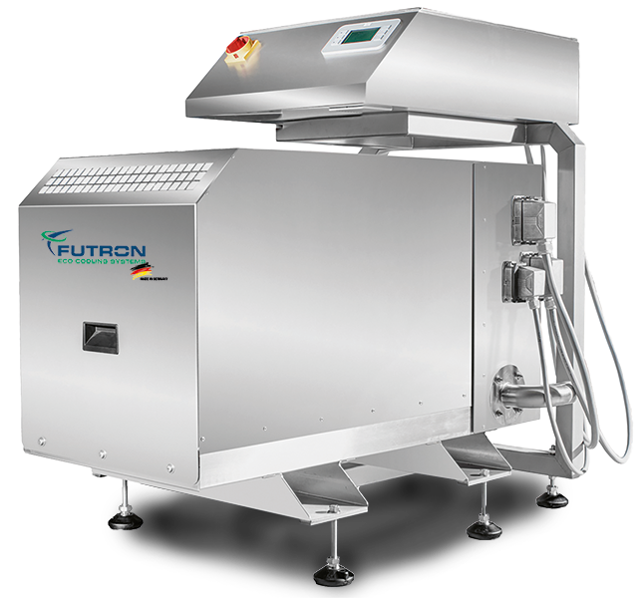
Illustration 1 MultiChiller example

Refrigeration machine xxx kW
Water-cooled liquid cooler for indoor installation in a compact design with natural refrigerants and minimal fill quantities.
Compact, quiet and reliable chiller with a ready-to-use refrigeration circuit and staged power control (optional FU). The natural and energy-efficient refrigerants R290, R1270 or R600a are used as refrigerants.

The MultiChiller can be used as a single device or when using multiple devices in a hydraulic network. A high total cooling capacity and redundancy are thus available. Up to 8 MultiChillers can be controlled in a network. The MultHydro MH (available separately) is used for interconnection. A MultiHeatRecovery MHR (available separately) for heat recovery and a MultiHydroSwitch MHS (available separately) can also be used as a hydraulic separator for decoupling.

Due to the special design and component selection, an extremely low refrigerant charge is required, which is <40g/kW cooling capacity. Depending on the cooling capacity, the refrigerant charge is only 0.5 to 2.4 kg. The MultiChiller has its own MultiControl (MCon) control. Thanks to its compact dimensions and special safety system, the MultiChiller can be installed indoors despite the use of flammable refrigerants.
No refrigeration personnel are required for installation and maintenance.

Housing
The housing of the MultiChiller is made of rustproof stainless steel and is supplied on four height-adjustable feet with vibration dampers. This makes it possible to compensate for uneven floors and the MultiChiller can be adjusted to the position of the on-site connecting pipes. The MultiChiller is designed for safe transport with a pallet truck or forklift. The housing cover is removable for service purposes.
According to EN 378, the housing is considered a “ventilated housing”.

Compressor
Semi-hermetic reciprocating compressor with high efficiency, thermal protection thermostat per cylinder cover, engine protection, oil sump heating, rubber vibration damper, oil pump and special oil filling. The compressor is specially approved for use with hydrocarbons. The power control is carried out as standard with a power controller (cylinder deactivation).

Plate heat exchanger
The multi-channel plate heat exchanger combines the functions of evaporator, condenser, subcooler and superheater. The refrigerant overheating is measured directly in the multi-channel plate heat exchanger after the evaporator. As a result, a small and safe refrigerant overheating can be measured. Thanks to this unique design, the expansion valve provides stable regulation without disruptive influences from the suction gas superheater.

Refrigeration cycle
In addition to the central components, the cooling circuit includes compressors and multi-channel plate heat exchangers, an electronic expansion valve as standard, temperature sensors, pressure sensors for high and low pressure, service valves for high and low pressure, depending on the version, pressure monitors, pressure limiters, safety pressure limiters. The cold-conducting components are provided with closed-cell insulation. All components are suitable and approved for use with hydrocarbons.

Type-tested security systems
A safety trough is integrated in the closed housing base of the refrigeration unit. The components of the refrigeration circuit are installed above this. Any refrigerant that escapes can be retained in this sump. The system is equipped with a two-stage gas warning device (ATEX). The gas warning system is part of the safety concept. It is a separate circuit which, in the event of an increased refrigerant concentration, switches on the safety fan for extraction in the first stage and can output a message to a permanently manned location via the control system. The MultiChiller remains in operation. When the second warning threshold is reached, the safety fan remains switched on and the entire MultiChiller is de-energized by the external control. A message can be issued to a permanently manned position.

Purchaser connections
The brine connections are made using standardised Victaulic® connections. The connection pipes on the MultiChiller are equipped with flexible pipe sections (compensators). As a result, small dimensional differences between MultiChiller and on-site connections can be compensated and any vibrations dampened. The Victaulic® connections enable simple and quick installation and removal by the installer.

Control (MultiControl)
The control cabinet with the control included is positioned above the MultiChiller, is positioned separately above the MultiChiller and forms an optical unit. Like the chiller, the housing is made of stainless steel. The control is a PLC that has been specially programmed for the function of the chiller. The high-quality Siemens Climatix components can be used as a group or individual control. The power control of the chiller takes place via a step switch (cylinder switch-off). Alternatively, frequency control is possible. With a compound control, up to 8 MultiChillers can be controlled. Chiller and controller are connected to each other via a coded connector system. These enable simple and error-free connection, without installation work by an authorised electrician.

Control main components:
- Main switch with emergency stop function
- Soft start for motor current limiter
- Circuit breaker
- Siemens Climatix control modules
- High quality control cabinet components
- incl. 1x control element Siemens POL 8xx for operation and fault evaluation
- 1x SD card for updating app and firmware Local service plug for
- User interface, installed software, control of MultiChiller
- Control of the electr. expansion valves
- Control of the flow temperature (cold or warm) by stepping the chiller
- Connection control of 2 or more chillers
- Access via Modbus TCP or RTU
- Access via Ethernet and HMI for Web
- Optional access via BACnet IP or MSTP
- Optional frequency converter made by Danfoss or equivalent

Equipment
- Semi-hermetic reciprocating compressor
- Multichannel plate heat exchanger
- Lowest refrigerant charge, less than 2.5kg
- Electronic expansion valve
- Depending on the model, pressure switches, pressure limiters, safety pressure limiters
- Two-stage gas warning system ATEX
- Safety suction
- Pressure sensors, temperature sensors
- Service connection high pressure, low pressure
- Tripping device motor protection
- Thermal protection thermostat on the cylinder head
- Oil sump heater
- Power controller
- Secondary connections using standard Victaulic® and compensators
- Stainless steel housing
- Adjustable feet with vibration dampers
- Basic module with its own Siemens Climatix control
- Communication possible via BUS system
- Remote monitoring possible
- Plug`n`Play via Victaulic® connection of the pipeline and plug system for the control and power supply
Temperature cold (forward / return) | °C | Bitte eintragen
Temperature warm (forward / return) | °C | Bitte eintragen
Maximum ambient temperature | °C | Bitte eintragen
Minimum ambient temperature | °C | Bitte eintragen
Cooling capacity | kW | Bitte eintragen
Condensing capacity | kW | Bitte eintragen
Power consumption in the design point | kW | Bitte eintragen
EER |  | Bitte eintragen
Current consumption at the design point | A | Bitte eintragen
Maximum electrical absorption | A | Bitte Auswählen
Mainhost power supply | V / PH / Hz | 380-420V Y/YY -3- 50Hz
Refrigerant |  | Bitte Auswählen
Refrigerant charge | g | Bitte Auswählen
Compressor type |  | semi-hermetic reciprocating compressor
Number of compressors |  | 1
Power levels frequency converter |  | Bitte Auswählen
Type |  | Multi-channel plate heat exchanger (soldered)
Material |  | stainless steel/copper
Number |  | 1
injection valve |  | Bitte Auswählen
Cold transfer medium |  | Bitte eintragen
Volume flow | m³/h | Bitte eintragen
Pressure drop | kPa | Bitte eintragen
Heat transfer medium |  | Bitte eintragen
Volume flow | m³/h | Bitte eintragen
Pressure drop | kPa | Bitte eintragen
Gas detection system |  | 2-stage – ATEX
Safety exhaust |  | Exhaust fan for combustible gases
forward / return cold |  | Victaulic 42,4 - TYP75 flexible
forward / return warm |  | Victaulic 42,4 - TYP75 flexible
Connection power supply |  | Machine connector Phoenix HC-B
Control connection |  | Machine connector Phoenix HC-B
Connection of sensors / gas warning system |  | Machine connector Phoenix HC-B
Suction safety device pipe |  | Pipe DN50
Floor mounting |  | 4x feet with vibration damper (height adjustable)
Sound pressure level in 5m | dB(A) | Bitte Auswählen
Sound measurement acc. to DIN 45635 -1:1984-04 | dB(A) | Bitte Auswählen
D-Bus-Interface |  | Bitte Auswählen
CPU |  | Siemens Climatix
Visualisation |  | Bitte Auswählen
Length | mm | Bitte Auswählen
Width | mm | Bitte Auswählen
Height with vibration dampers | mm | 782
Transport weight | kg | Bitte Auswählen

Proof of delivery:
FUTRON GmbH
Elisabethstraße 29 Phone +49 37 65 38 03-0
08491 Netzschkau info@futron-gmbh.de
Germany

