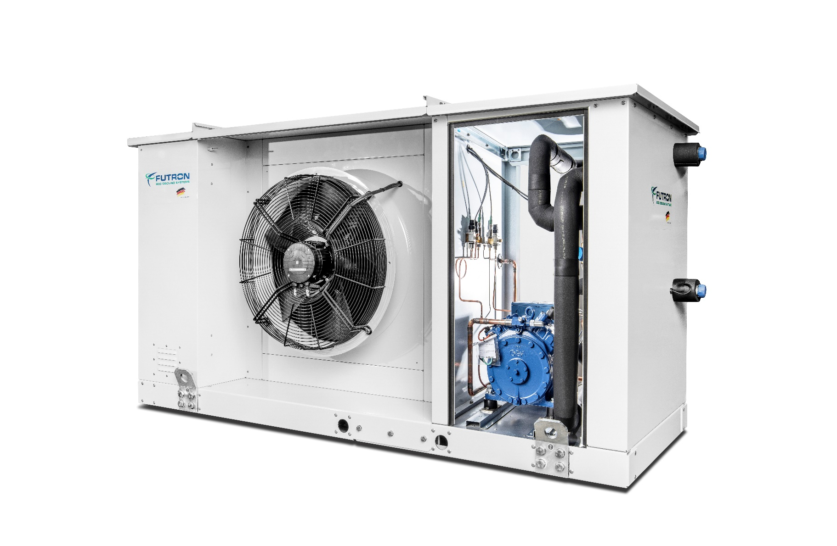

Illustration 1 MultiAirChill example

**Refrigeration machine** xxx kW

Air-cooled liquid cooler for outdoor installation with natural refrigerants and minimal fill quantities.

Liquid chiller with a refrigeration cycle ready for delivery and staged power control (optional FU). The natural and energy-efficient refrigerants R290 or R1270 are used as refrigerants.

The MultiAirChill (MAC) has a condenser that is optimized for filling quantities. The appropriate equipment is selected depending on requirements and performance requirements. The brine/consumer pumps required on site can be enabled via a control signal. The brine chiller is suitable for high ambient temperatures >40°C and is supplied as a ready-to-connect unit. Heat recovery using the heat recovery energy is available as an option.

**Housing**

For the outdoor installation, the housing is provided with a high-quality powder coating and sound insulation. The components of the control cabinet, refrigeration with hydraulics and dry cooler are spatially separated from each other. The MEC is supplied on six height-adjustable feet with vibration dampers. This makes it possible to compensate for uneven floors and the MultiChiller can be adjusted to the position of the on-site connecting pipes. Cranes and forklifts are available for safe installation. There are inspection openings for service purposes.

**Compressor**

Semi-hermetic reciprocating compressor with high efficiency, thermal protection thermostat per cylinder cover, engine protection, oil sump heating, rubber vibration damper, oil pump and special oil filling. The compressor is specially approved for use with hydrocarbons. The power control is carried out as standard via step control (cylinder deactivation). Frequency control is optionally available.

**Evaporator**

A soldered plate heat exchanger with a refrigeration circuit and a brine circuit is used for dry evaporation. Patented ducting and the structure of the refrigerant distributors ensure maximum efficiency. The heat exchanger is completely closed cell insulated.

**Internal heat exchanger**

The internal heat exchanger (overheating / subcooling) ensures significantly increased efficiency and safe operating behavior. The integration takes place via the respective suction gas and liquid line of the refrigeration circuit and leads to the liquid refrigerant being undercooled upstream of the expansion valve.

**Condenser**

In the case of direct liquefaction, a liquefier-optimized condenser is used. This enables low refrigerant charge. The condenser is integrated in the MAC housing and equipped with low-noise and maintenance-free EC fans. The drive motor, the fan blade and the supporting protective grille construction form an optimal ventilation unit. The EC fans ensure high energy efficiency via the condensing pressure control. All axial fans have a separate repair switch and are easy to service.

**Refrigeration cycle**

In addition to the central components, the refrigeration circuit includes compressors and plate heat exchangers, an electronic or thermostatic expansion valve as standard, temperature sensors, pressure sensors for high and low pressure, service valves for high and low pressure, depending on the version, pressure switches, pressure limiters and safety pressure limiters. The cold-conducting components are provided with closed-cell insulation. All components are suitable and approved for use with hydrocarbons.

**Type-tested security systems**

A safety trough is integrated in the closed housing base of the refrigeration unit. The components of the refrigeration circuit are installed above this. Any refrigerant that escapes can be retained in this sump. The system is equipped with a two-stage gas warning device (ATEX). The gas warning system is part of the safety concept. It is a separate circuit which, in the event of an increased refrigerant concentration, switches on the ATEX-safety fan for extraction in the first stage and can output a message to a permanently manned location via the control system. The MAC remains in operation. When the second warning threshold is reached, the safety fan remains switched on and the machine part of the system is switched off by the control system. A message can be issued to a permanently manned position.

**Control**

The control cabinet with the included control has a clear separation from the refrigeration circuit. This is positioned on the front of the device and forms an optical unit. The control is a PLC that has been specially programmed for the function of the MAC. The high-quality Siemens components are used as a control system. The output control of the MAC takes place via a step switch (cylinder switch-off). Alternatively, frequency control is possible. The visualization and fault evaluation is carried out via a Siemens POL 8xx control panel.

**Control main components:**

* Main switch with emergency stop function
* Soft start for motor current limiter
* Circuit breaker
* Thermostat and integrated fan for a ventilation
* Automatic circuit breakers for every consumer
* Siemens Climatix control modules
* High quality control cabinet components
* incl. 1x control element Siemens POL 8xx for operation and fault evaluation
* 1x SD card for updating app and firmware Local service plug for user interface, installed software, control of MultiChiller
* Control of the electr. expansion valves
* Control of the flow temperature (cold or warm) by stepping the chiller
* Access via Modbus TCP or RTU
* Access via Ethernet and HMI for Web
* Optional access via BACnet IP or MSTP
* Optionally with frequency converter

**Equipment**

* Semi-hermetic reciprocating compressor
* Multichannel plate heat exchanger
* Capacity-optimized condenser
* Electronic or thermostatic expansion valve
* Depending on the model, pressure switches, pressure limiters, safety pressure limiters
* Two-stage gas warning system ATEX
* Safety suction
* Pressure sensors, temperature sensors
* Service connection high pressure, low pressure
* Tripping device motor protection
* Thermal protection thermostat on the cylinder head
* Oil sump heater
* Power controller
* High quality coated housing for outdoor installation
* Adjustable feet with vibration dampers
* Basic module with its own Siemens Climatix
* Communication possible via BUS system
* Condenser with EC fans
* Plug`n`Play via flange connection of the pipeline and plug system for the control and power supply
* Optional heat recovery
* Optional remote monitoring possible

|  |  |  |
| --- | --- | --- |
| Temperature cold (forward / return) | °C | Bitte eintragen |
| Air inlet ambient temperature | °C | Bitte eintragen |
|  |  |  |
| Maximum ambient temperature | °C | Bitte eintragen |
| Minimum ambient temperature | °C | Bitte eintragen |
|  |  |  |
| Cooling capacity | kW | Bitte eintragen |
| EER |  | Bitte eintragen |
| Mainhost power supply | V / PH / Hz | 380-420V Y/YY -3- 50Hz |
| Maximum electrical absorption | A | Bitte eintragen |
| Refrigerant cycle |  | Bitte eintragen |
| Refrigerant |  | Bitte Auswählen |
| Refrigerant charge (apiece Refrigerant cycle) | g | Bitte eintragen |
| Cold transfer medium |  | Bitte eintragen |
|  |  |  |
| Compressor type |  | semi-hermetic reciprocating compressor |
| Number of compressors |  | Bitte eintragen |
| staged power control |  | Bitte Auswählen |
| Total Power consumption | kW | Bitte eintragen |
| Power levels frequency converter | A | Bitte eintragen |
| Maximum electrical absorption (apiece compressor) | A | Bitte eintragen |
|  |  |  |
| Type |  | Aluminum finned |
| Material (Pipe) |  | copper |
| Fan number |  | Bitte eintragen |
| Fan type |  | Bitte eintragen |
| Total Power consumption | kW | Bitte eintragen |
|  |  |  |
| Type |  | Multi-channel plate heat exchanger (soldered) |
| Material |  | stainless steel/copper |
| Number |  | 1 |
| Injection valve |  | Bitte Auswählen |
| Volume flow Cold transfer medium | h³/h | Bitte eintragen |
| Pressure drop | kPa | Bitte eintragen |
|  |  |  |
| D-Bus-Interface |  | Bitte Auswählen |
| CPU |  | Siemens S7 |
| Visualisation |  | Bitte Auswählen |
|  |  |  |
| Gas detection system |  | 2-stage – ATEX |
| Safety exhaust |  | Exhaust fan for combustible gases |
|  |  |  |
| forward / return cold |  | flange connection DN xx bolt circle-Ø xxx mm |
| Connection terminals supply line * |  | Connecting terminal plate 3L+N+PE |
| Floor mounting |  | 6x feet with vibration damper (height adjustable) |
| * The cable cross-section is to be calculated according to the applicable regulations and can vary depending on the cable length,  type of installation and other factors. | | |
|  |  |  |
| Length | mm | Bitte eintragen |
| Width | mm | Bitte eintragen |
| Height with vibration dampers | mm | Bitte eintragen |
| Transport weight | kg | Bitte eintragen |